Virginia Mennonite Missions
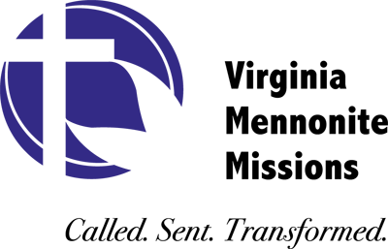
Strategic Planning Process – 2012-13

QUESTIONS FOR DELEGATES

1. | What mission resourcing is so valuable to you as a congregation that you would be willing to double your contributions to VMMissions if we would provide it?
2. | Do the priorities of “least reached” and “least of these” provide a useful filter for determining the footprint and locations of ministry? What other filters would be helpful?
3. | As we look to create sustainable ministry models for the future, would a bi-vocational approach appeal to you or others in your congregation? What other approaches might you suggest?
4. | What are the current factors that limit greater diversity of age, gender and ethnicity among board, staff and workers? How might we better overcome them?
5. | Should VMMissions deliberately seek additional supporting partners who would have an affinity for an Anabaptist approach to mission? Why or why not?
6. | What gifts does the global church have to offer us that we have not yet received?
7. | How can VMM help your congregation engage for mission in your local community? What else would you like to tell us as we consider the future of VMMissions?

